A cascade control structure is often used for the toque control of the motor system, where the current controller serves as the subordinate controller, and the torque controller serves as the superposed controller. The torque controller generates the reference points for the d-axis and q-axis current based on the targeted torque value and the rational speed, and the reference current are given to the current controller as setpoints, so that the target toque is achieved.

***[block diagram of controller system]***

In convention, the generation of the current reference is an offline method, which means that each operating points of id and iq for each Torque value in the whole operating range is stored in the controller, so that no online calculation is needed. This is realized through

is calculated and optimized beforehand.

These data contain the information of inductivity in the d-axis and q-axis of the motor

inductance saturation

*The most used method -> offline, look up table*

*What is LUT? -> optimized data points based on inductivity Ld Lq*

*The content of LUT - > motor control,field wekening area -> MTPA and MMPV*

*MTPA, MA ,MTPV*

*Explain Torque curve, voltage curve, relation of rotation speed and voltage limit*

*[block diagram of controller system with look up table]*

*[M-N kennlinie]*

*Advantage of LUT?*

* *Low computing power needed*
* *Guarantee a stable control result / predictable control result*

*Disadvantage off LUT*

* *Deiviation of LUT leads to diviation in control result*
* *Diviation caused by temperature (site Development of FW and MTPV Control for*
* *SynRM via Feedforward Voltage Angle Control)*

Index

* + - Problem with LUT method
      * Energy inefficiency in FW region
      * Need for MTPV and M-N curve data from motor testing through test bench
  + Feedback methods
    - Objectives
      * Minimize copper loss in FW region
      * Current reference point
    - Controller design
      * Current set point calculation
      * Boundaries limitation and condition
        + MTPA / MTPV I / MTPV II
    - State operations and control goal
      * State definition and Control goal
        + MTPA / FW / MTPV I /MPTV II
      * Output value of each state
        + MTPA / FW / MTPV I /MPTV II
      * State switching logic
      * State flow model
  + Torque Observer
    - Torque Observer equations
    - ~~Validation with motor data~~
  + Filter design
    - Filter type comparison and selection criteria
    - Filter equations

4. Current Reference Generation through Feedback method

Field-Weakening Feedback control with optimal voltage utilization

Despite the various advantages of generating current reference based on Look-up-Tables as

Many research has been made on the topic of field-weakening control of the SynRM. The paper ….propsed a ….for….

In this research thesis, we focus on the Field-weakening region (FW region) for the torque control of SynRm. The proposed control method aims at tackle problems which are prominent when using LUT methods in the Filed-weakening region.

1. The need for test bench measurement for MTPV and M-N Table.
2. The operating point on MTPV are not optimized inn terms of voltage throughout whole range of Torque and rotation speed

For using LUT as the current reference for the torque controller, a serious of measurement are needed on the SynRm motor. The inductivity on the d- and q- axis , Ld and Lq, throughout the whole operating range of current on d- and q- axis shall be first measured, with which the MTPV data can be acquired through numeric methods. This offline method not only requires a comprehensive motor test bench, but also is time consuming.

Another problem when using the LUT methods is that the operating points are not optimized during most of the operating condition. When using the LUT methods in the FW region, the operating points of id and iq are always limited on the MTPV data points. The LUT gives the current setpoint which correspond to the Torque command given. Since MTPV setpoints is serious of datasets that gives the maximin Torque under a certain rotation speed where the maximin voltage reserve is utilized, when the operating rotation speed is lower than the corresponding rotation speed of the MTPV setpoint, the voltage utilization is not maximized. The following example illustrate this phenomenon.

Say the motor system is under the rotation speed w1. Under this condition, the voltage limit is Us1. The torque command for the motor control system is M2. The voltage curves and the Torque curves are as illustrated in fig? .

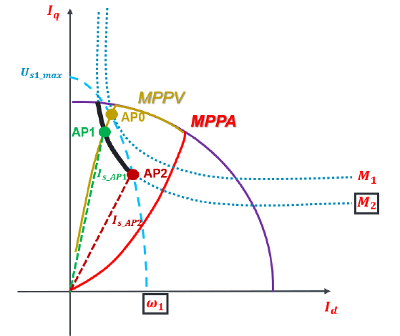***M1>M2 , w1>w2***

***[The operating point from LUT where the voltage is not maximized OP1]***

***[The operating point where the voltage is maximized OP2]***

With the LUT method, the operating point OP1 will be given with the corresponding torque value M2. However, the operating point does not lie on the voltage curves of Us1, which means that the voltage reserve is not fully utilized under this condition. On the other hand, operating point OP2 is the point, in which the torque command M2 can be generated but simultaneously the voltage utilization is maximized.

When comparing the point OP1 and OP2, we can infer that the current used in OP2 is significant smaller. According to equation in ***(equation number)***, the copper loss is minimized at operating point OP2.

***[Equation of copper loss due to current]***



For every operating condition (i.e. torque command value and the rotation speed of the motor) in the field-weakening region, there is an operating point where maximal voltage reserve is utilized and the copper lost is minimized. These operating points lie in the enclosed area of curve MTPA, MA and MTPV. The proposed method aims at fully utilized the operating area, so that the operating points are no longer restricted to the MA and MTPV curve and the motor torque control system gives the optimized current setpoint throughout the whole operating range without the MA and MTPV datasets.

In a LUT method, M-N Table is used to restrict the torque command value based on the rotation speed of the motor so that the operating point does not exceed the operating region. In the proposed method, we also aim to achieve this without the use of M-N Table.

Since this research does not focus on constant torque region, the MTPA datasets are still required in the proposed method. However, there are already research on the topic of online search method of the MTPA trajectories in ***[Tymosch’s Arbeit]***

4.1 Proposed Control Scheme through Feedback methods

In the paper ***[New Flux Weakening Control for High Saliency Interior Permanent Magnet Synchronous Machine Without Any Tables ]***, a flux weakening control strategy for PMSM using feedback voltage signal is proposed. Although no LUT is required in this control method, inductivity on the d, q axis is required for the parameter during the calculation of current reference. However, the inductivity value is easily influenced by other factors and will saturate…

In the paper ***[Flux Weakening Control for Synchronous reluctance Machines Based on Parameters Estimated at Stand-still***]

However,…….

In this thesis, a novel field-weakening control algorithms for SynRM proposed. This control method is able to plan the trajectory of the current reference vectors based on the motor speed and torque command along which the utilized voltage is optimized. Any Look-up-Tables in the FW region (i.e. MTPV,MA) or the inductivity infomation on the d- and q- axis of the motor are not required for this control method.

4.1.1 Control Goal

The trajectory of the current vector in the d- and q-axis is illustrated in fig ?. With a certain Torque command value and a increasing rotation speed, the operating point of the current vector will first be given by the MTPA Look-up-Table. As the speed increase, the operating point moves along the constant Torque hyperbolae or the current limit circle (corresponding the MA curve) depends on the magnitude of the current vector. In a higher rotation speed range, the operating points reach the MTPV line and gradually descend to the origin of the d-q axis as the speed increase.

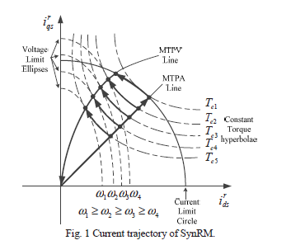

As the speed increases, the voltage limit ellipses become smaller, restricting possible operating points of the current vector within this ellipse. For the control method to be voltage optimized, every operating point in the Field-weakening region should have the maximum voltage utilization. The voltage optimized operating points can be hence determined as the intersection of the voltage limit ellipse and other curve, namely, the constant torque hyperbolae, MA curve and the MTPV curve depending on the torque command and the speed.

In order to operate through the Field-weakening region without the use of any Look-up-Table , criteria of operating region should be determined, since the directions and trajectory in which operating point moves in different regions are different. Note that the controller has no knowledge of MA and MTPV curve in the form of Look-up-Tables. The operating point is controlled along MA and MTPV curve through feedback methods.

4.1.2 Operating region and Boundaries

In this thesis, we defined operating region of the SynRM as one region and three boundaries. As shown in the fig?, the FW region is enclosed by three boundaries, MTPA,MA and MTPV. The operating points of current vector from the controller is always within these regions.

***[figure for operating regions and boundaries]***

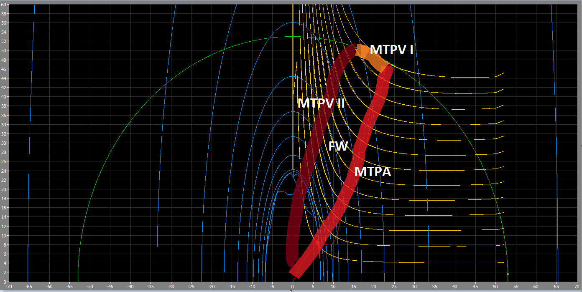

For the determination of which operation regions the motor is in, the conditions for each operating regions is defined. The trajectory and the control goals in each operating regions are also defined in this chapter.

In the operating region of MTPA, the operating points follows the trajectory given by the Look-up-Table according to the torque command given. For the operating point to be in the MTPA, the value of the current vector i_s must not exceed the maximum value of the operating current. The total voltage value v_s should also be under the maximum value of operating voltage, which means the motor speed is below a characteristic value (Eckdrehzahl).

***[equation for i_s<i_s_max, u_s<u_s_max]***

The MTPA region is for the operation in the basic speed region (Grunddrehzahlbereich) of the SynRm. When the speed exceeds the basic speed region, the motor operation goes in the field weakening region, which is characterized by the MA,MTPV and FW region.

In the operating region of MA, the current vector of the operating point has the maximum value of the operation current. The operating point in this region will follows the current limit circle, which is described in (equation number). Also, since the MA region is in the filed weakening region, the utilized voltage of the motor corresponds to the value of voltage limit.

***[equation for i_s = i_s_max, id = is*cos (i_phase),iq=is*sin(i_phase) ]***

The determination of MTPV region is more complex than the above two region. In definition, the MTPV is the point of contact between the voltage limitation ellipse ad the constant torque hyperbola. In [paper number] ***[Flux Weakening Control for Synchronous reluctance Machines Based on Parameters Estimated at Stand-still***], the MTPV region is determined by the angle between constant torque direction and the voltage decreasing direction. However , calculation of such angle requires the value of inductivity in the d- and q- axis, which in this paper are estimated value Based on standstill measurement. Consider the saturation effect of the inductivity and the need for measurement of the motor, we chose another method in this paper for the determination of the MTPV region. As in ***[An Improved Robust Field-Weakeaning Algorithm for Direct-Torque-Controlled Synchronous- Reluctance-Motor Drives] [Predictive Stator Flux and Load Angle Control of Synchronous Reluctance Motor Drives Operating in a Wide Speed Range],*** the MTPV region is characterized for voltage angle equals to 45 degree. The following equations shows the reason for this condition.

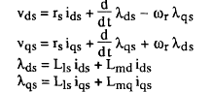

 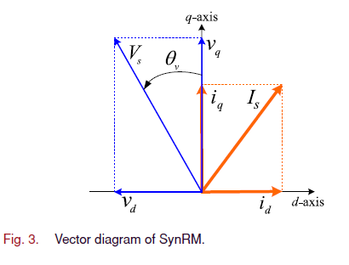

Considering that in higher roation speed regions, the voltage of resisotr is neglectable compared to the the volage induced from the Flux. We can refmorulate equaiton ? and ? in to ?

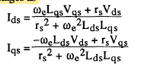

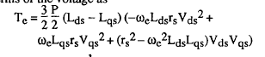





Consider that the difference in the inductivity term for different id,iq value is small , and since the voltage in MPTV region always equals to the voltage limit, for given rotation speed ,we can derive this equation.

***[Te = constat_value * sin (2*voltage phase angle)***

,which shows that the torque value is maximum when voltage angle = 45 degree. Hence, we use this characteristic as reference for the MTPV curve and define the MTPV region as the operating points where the voltage angle is 45 degrees.

Since the saturation in conductivity relative small compared to ….

[add content for pull-out torque]

[definition of load angel and voltage phase]

The FW region is defined as the region which is enclosed by the line MTPA, MA and MTPV, where the voltage limit is reached, the current vector is lower than the current limit, and the voltage angle has not yet reach 45 degrees. The operating points follows the constant torque curve for a given Torque command and increasing speed in the region.

The condition of each operating region and the trajectory the operating point follows is shown in Table ?

|  |  |  |
| --- | --- | --- |
|  | condition | ***trajectory*** |
| MTPA |  | LUT |
| FW |  | Follow the constant torque curve |
| MA |  | Follow the current limit circle |
| MTPV |  | Follow the curve where phase_V = 45 degree |

4.1.3 Boundary crossing condition and operating routes

For the operating regions defined above, the crossing condition between the operating region should also be defined to enable a smooth transition between regions during motor operation in the Filed-weakening region. As showed in fig?, five boundaries between the operating region can be defined.

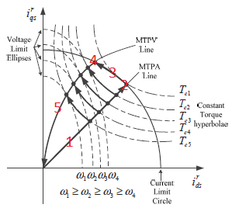

For each boundaries we defined crossing conditions for

|  |  |  |  |
| --- | --- | --- | --- |
|  |  | Crossing condition | Satisfied condition |
| 1 | MTPA->FW | u_s >= k_u * u_s_limit && i_s <k_i*i_s_limit |  |
| 2 | MTPA->MA | u_s >= k_u * u_s_limit && i_s >=k_i*i_s_limit |  |
| 3 | FW ->MTPV | u_phase >=45 | u_s >= k_u * u_s_limit |
| 4 | FW ->MA | i_s >=k_i*i_s_limit | u_s >= k_u * u_s_limit |
| 5 | MA ->MTPV | u_phase >=45 && i_s <k_i*i_s_limit | u_s >= k_u * u_s_limit |

From the operating region defined above, we are able to define

***[SHOW 3 LINES:MTPA->MA->MTPV, MTPA->FW->MA->MPTV,MTPA->FW->MTPV]***

|  |  |  |
| --- | --- | --- |
| Vorgang | Torque | Rotation Speed |
| MTPA -> FW ->MTPV II | M=20 | N=0-4460 min^-1 |
| MTPA -> FW ->MTPV I | M=45 | N=0-3200 min^-1 |
| MTPA -->MTPV I ->MTPV II | M=65 | N=0-6000min^-1 |

Fig ? shows the ideal characteristics of the for the operation described in this

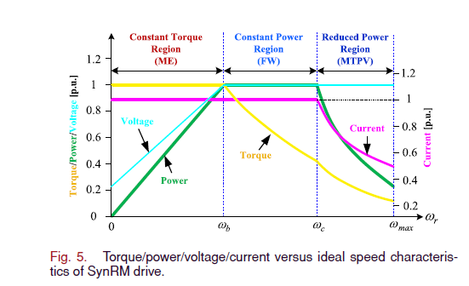

4.1.4 Current Reference modification

For the field-weakening operation, the operating point of current vector i_s is moved through the region of FW, MA and MTPA for the optimal operation of the SynRM. This is carried out using a feedback control method, where the direction and distance in which the operating point travels are decide through the error signals of Voltage, Torque and Voltage angles. We defined these error signal in [equation numbers]

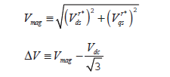

In the basic speed region (Grunddrehlzahlberiech), the current reference is given from the MTPA look-up-Table according to the value of the torque command. Upon entering the Field-weakening region, the current reference is modified based on the reference value Id|MTPA and Iq|MTPA.

The modified current reference can be described as



Where the modification current idm and iqm can be obtained through integration of the modification magnitude Md and Mq over time, as shown in [equation num]



For operation in different operating regions in the field-weakening region, i.e. FW ,MA,MTPV , the modification magnitude Md and Mq are different, since the controlling goal and the trajectory that the operating point follow for each region is different. The modification magnitudes are shown in [equation num]

The controller uses an online- calculating approach, rather than a model base and analytical approach. The reason for that is to avoid using motor parameters such as Induction n the d- q- axis for the control of the motor, thus avoiding any measurement needed on the motor. Since model-based control requires data of the motor and will very likely introduce instability through inaccuracies in the measurement data. This approach is more robust since it is hardly affected by inaccuracies of the measurement and also the deviation in the motor of the same design caused by production.

In the FW

In the MA region, the current vector follows the current limit circle, where the id and iq value can be described as in [equation num] below,

From [equation num] , we can derive [equation num]

The Md and Mq value can be derived through differentiation with time,

Since the controller uses Normalized current value

and ,

We can rewrite Md and Mq value as,

Comparing equation ? and equation ? , we can see that the feedback control value correspond to the term . In other word, we use the voltage error to control the rotational speed of the current vector traveling on the current limit. When the voltage error converges to 0 , the current vector stop traveling on the current limit. Since the feedback value is negative when the current angle increase, the equation is negated in ?.

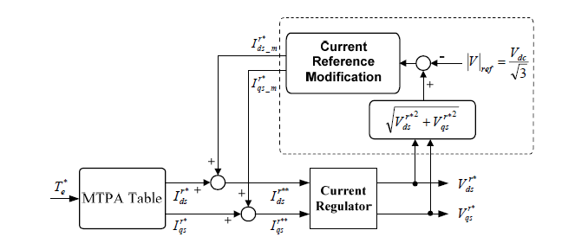

***[Block of the torque controller ;something like this. Add I signal and M signal and V_theta]***

4.2 OFM Algorithm Implementation

OFM uses the simulik state flow structure to model each boundaries condition as states.

The advantage of using state flow model lies in its discrete characteristics,

State flow model

Filter

Torque observer

Where the

4.2.1 Stateflow model

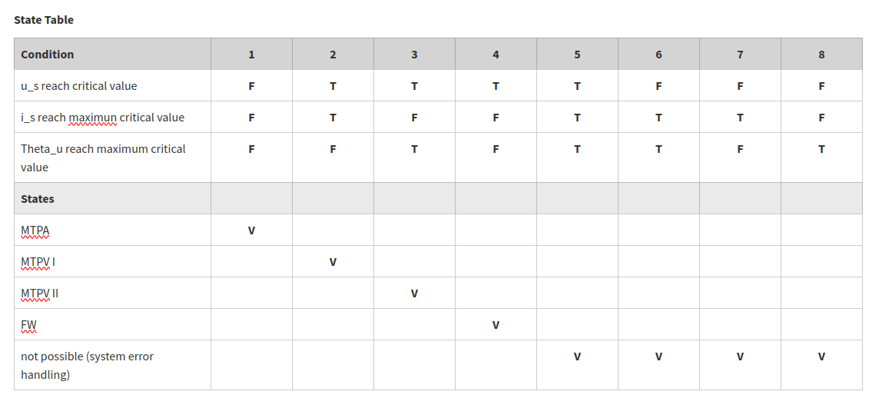State table of

Model and simulate decision logic using state machines and flow charts

Stateflow is a toolkit form Matlab that is capable of inplementation of state machines and flow chart within simulink models. It provides a graphical interface for user to design state transition diagrams, flow charts, state transition tables, etc.

The Stateflow model can take input signals, events, and time-based conditions from the otter Simulink model and simulate conditional, event-based, and time-based logic.

The advantage of the Stateflow model lies in its time-discrete characteristic.

The stateflow model work complete in discrete time, which boost great advantage for real-time application

You can model conditional, event-based, and time-based logic in Stateflow to invoke Simulink algorithms in a periodic or continuous manner. Orchestrate the execution of components to simulate the scheduling of your real-time environment.

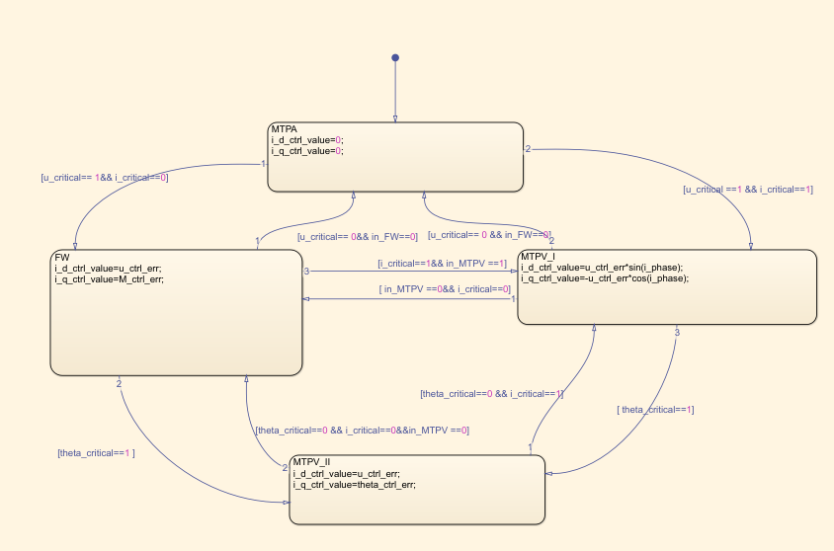

4.2.1 Torque estimation

Since application of this control method should also be possible for real-world applications, such as the motor drive in vehicle power-train system, the torque signal should not be measured and collected form a torque meter, which is normally available in vehicle application. Hence , estimation of the motor torque should be made within the system in real-time.

4.2.3 Filter

4.3 Stability Analysis